Parade Map for web page

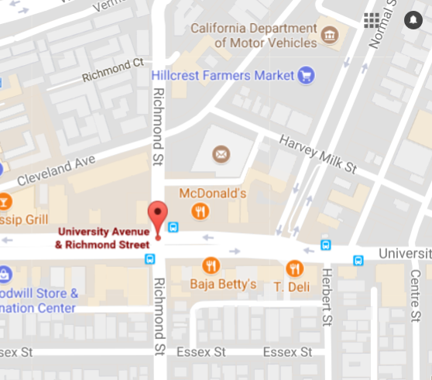
2
1

1
Shuttle Stop
2

Accessible Seating Area

Rally Map for web page

2
Rally Location, Accessible Seating Area

2
Pay to Park - Accessible parking at the DMV

