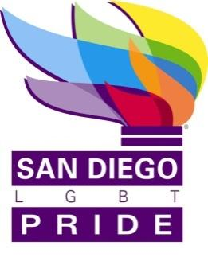
APPROVAL & REVISION HISTORY

Release Date | Expiration Date | Rev | Revised By | Revision Description
 | None | 1 | J.Carrillo | Initial Document

TABLE OF CONTENTS
1. Purpose
2. Definitions
3. Attendance
4. Minutes
5. Certification

TABLE OF FIGURES
Figure 1 Director Attendance (4 is the minimum required for a quorum)
Figure 2 Staff and Guest Attendance

Purpose
These are the minutes for the meeting of the Board of Directors held on August 31, 2016 located at the Principal Office.

Definitions

Term | Definition
LGBT | Lesbian, Gay, Bisexual, Transgender
SD | San Diego
ED | Executive Director
PSP | Policy and Strategic Planning Committee
BD or BDC | Board Development Committee
BPC | Balboa Park Centennial Committee

Attendance

Figure 1 Director Attendance (6 is the minimum required for a quorum)
Name | Title | Present | Absent
Bianca Burt | Co-Chair | X
Jaime Carrillo | Secretary | X
M. Verdeflor | Treasurer | X
Nenette Agulto | Director | X
Brett Granfield | Director | X
James Seal | Director | X
Lynne Barnes Wallace | Director | X
Jeri Dilno | Emeritus | X
^{C} Leave of absence
² Via telephone
Figure 2 Staff and Guest Attendance
Name | Title | Present | Absent
Stephen Whitburn | Executive Director | X
Craig Knutsen | South Bay Pride Treasurer | X
Joe Burke | South Bay Pride ED | X

Minutes
B. Burt called the meeting to order at 6:15 PM
P Jackson read the mission and vision statement
J. Carrillo made a motion to amend the agenda and give staff time to speak. Seconded by Nenette Agulto. Without objection motion carried.
Staff provided feedback on employee situation.
M Verdeflor arrived at 621 PM
Staff left the room at 623 PM
Entered executive session at 624 PM
Exited executive session at 7:31 PM.

D. Moore left.

An ad hoc committee was created to address transition: M.Verdeflor, J Dilno, J Carrillo and L Barnes- Wallace to be chaired by J Dilno.
There was an update on the 2015 audit.
AIDS Walk is on 9/24/16.

The meeting was adjourned at 7:54 PM.
Certification
I certify that these are the true and correct minutes of the Board of Directors Meeting held on August 31, 2016.

Jaime Carrillo
Secretary of San Diego LGBT Pride

