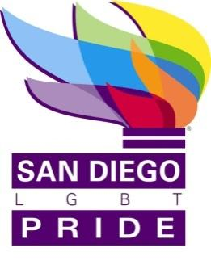
APPROVAL & REVISION HISTORY

Release Date | Expiration Date | Rev | Revised By | Revision Description
 | None | 1 | J.Carrillo | Initial Document

TABLE OF CONTENTS
1. Purpose
2. Definitions
3. Attendance
4. Minutes
5. Certification

TABLE OF FIGURES
Figure 1 Director Attendance (4 is the minimum required for a quorum)
Figure 2 Staff and Guest Attendance

Purpose
These are the minutes for the meeting of the Board of Directors held on September 21, 2016 located at the Principal Office.

Definitions

Term | Definition
LGBT | Lesbian, Gay, Bisexual, Transgender
SD | San Diego
ED | Executive Director
PSP | Policy and Strategic Planning Committee
BD or BDC | Board Development Committee
BPC | Balboa Park Centennial Committee

Attendance

Figure 1 Director Attendance (6 is the minimum required for a quorum)
Name | Title | Present | Absent
Bianca Burt | Co-Chair | X
Jaime Carrillo | Secretary | X
M. Verdeflor | Treasurer | X
Nenette Agulto | Director | X
Judi Schiam | Emeritus | X
James Seal | Director | X
Lynne Barnes Wallace | Director | X
Jeri Dilno | Emeritus | X
^{C} Leave of absence
² Via telephone
Figure 2 Staff and Guest Attendance
Name | Title | Present | Absent
Fernando Lopez | Operations Director | X
Bob Leyh | Festival manager | X
Joseph Smith | Medical Director | X

Minutes
The meeting was called to order by B. Burt at 6:02 PM
N. Agulto read the mission and vision statements.
Guests excused and asked to return at public board meeting.

603 PM Entered executive session.
Exited executive session at 7:26 PM.
J. Carrillo made a motion to approve the staff hire of an entertainment director. Seconded by M. Verdeflor. Motion carried without objection.
F. Lopez has been invited to go to the Phillipine Islands to represent SD Pride.
Adjourned at 7:27 Pm.

Certification
I certify that these are the true and correct minutes of the Board of Directors Meeting held on August 31, 2016.

Jaime Carrillo
Secretary of San Diego LGBT Pride

